DAVID KROEGER

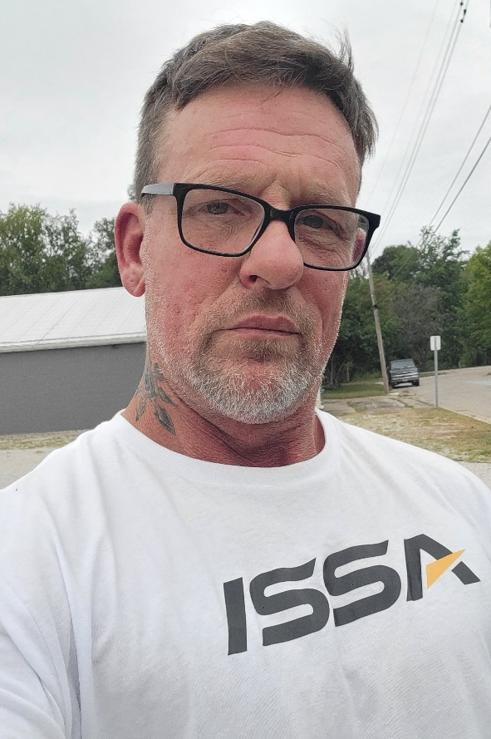My name is David Kroeger an ISSA Certified Personal Trainer with a passion for helping others lead healthier and more fulfilling lives. With my experience and expertise is creating personalized programs that empower clients in a way that help them achieve their goals. My approach focuses on building strength, improve mobility, and fostering sustainable habits that support long term health. I am dedicated to guiding each person to a stronger and healthier self!

**CERTIFICATIONS:** ISSA Certified Personal Trainer, AED/CPR, ISSA Nutrition Certified (in Progress)

**AVAILABILITY:** Monday-Friday after 3:30pm

Saturday & Sunday: All day

# CONTACT:

**•Email:** [darkdave72is@gmail.com](mailto:darkdave72is@gmail.com)

**•Phone:** 573-619-6552

# SESSION COST & DURATION OPTIONS:

|  |  |  |
| --- | --- | --- |
| **SESSION COST** | **DURATION** | **NUMBER OF SESSIONS** |
| $50/session | 60 minutes | 1 |

**For more information, contact Quinton Sallin, YMCA Wellness Director, at** [**qsallin@jcymca.org**](mailto:qsallin@jcymca.org) **or 5737613225.**